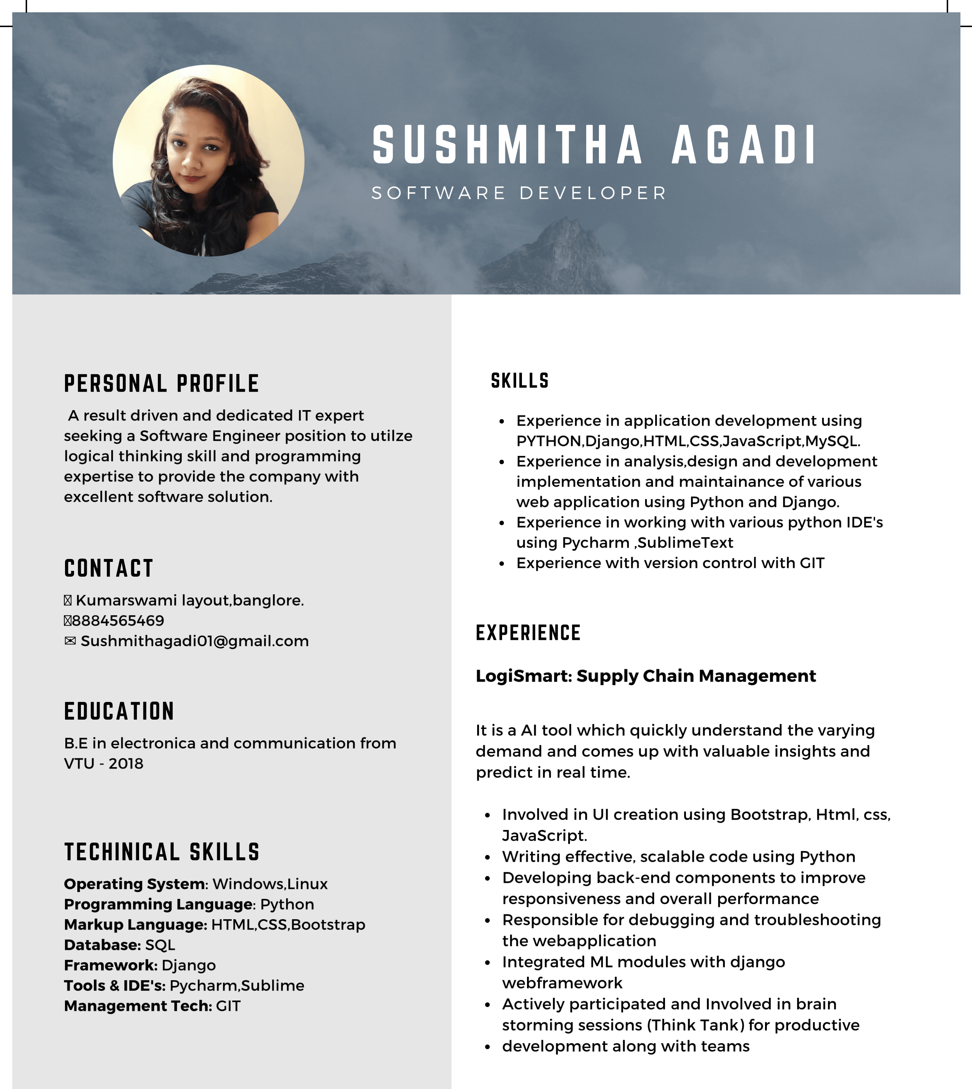

**PROFESSIONAL SUMMARY:**

●1+ years of experience as a Web/Application Developer with a clear understanding of technology trends with expertise in the core of complex technologies.

● Experience in analysis, design, and development, implementation and maintenance of various web applications using Python and Django.

● Experience in application development using **PYTHON, Django, HTML5.**

● Experience in working with various Python IDE's using **PyCharm, Sublime Text**.

● Experience with Version Control with **GIT**.

● Experience in working with different operating systems like **Windows, Linux**.

● Experience in implementing **PEP8** coding standards.

● Excellent **interpersonal** and **communication skills**, **efficient time management** and **organization skills**.

● Ability to handle multiple tasks and work well in a team environment.

● Highly **motivated**, **dedicated**, **quick learner** and have proven ability to work individually and as a team.

● Actively participated and Involved in brain storming sessions (Think Tank) for productive development along with teams.

● Followed Agile testing methodology, participated in daily Scrum meetings.

● Ability to adopt new technologies and handle tight schedules.

**PROFESSIONAL EXPERIENCE:**

**Radometech**

**Software Engineer**

**DESCRIPTION:**

**1.** **Forecasting using hystoric data**

**Tools /Technology :** Python, Django, Flask, Pandas, Jinja, Bootstrap4, CSS3, HTML5, JavaScript, Highcharts

**Role : Software developer**

**Duration : July** 2019– dec 2020

**Forecasting using hystoric data:** Predicting inventory stocks in advance by using pattern recognization from hystoric inventory data

**RESPONSIBILITIES:**

● Understanding the Business Requirement Specifications

● UI creation using Bootstrap, Html, css, JavaScript.

● Writing effective, scalable code using Python

● Developed user facing elements

● Integration of user-facing elements developed with server-side logic

**Mini-Projects**

**Project Login System in Django (Mini Project)**

**Application** Django based Web applications

**Description** Implementing the basic template of Login System with Django Authentication

**EDUCATIONAL QUALIFICATION**

* Bachelor of Engineering in Electronics and Communication at Visvesvaraya Technological University in 2018.
* PUC: PU Board, Adarsh PU college, Hubballi.
* SSLC: Karnataka secondary Board, Navanagar Rotary English Medium School, Hubballi

GitHub : <https://github.com/sushagadi19>

Linkidin : <https://www.linkedin.com/in/sushmitha-agadi-00233414b>

**DECLARATION:**

I consider myself familiar & I am confident of my ability to work in team. I hereby declare that the information furnished above is true to best of my knowledge.

SUSHMITHA AGADI